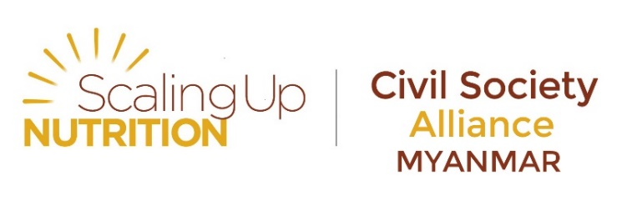

Membership Terms and Reference
Scaling Up Nutrition Civil Society Alliance (SUN CSA) Myanmar
Civil society organizations collectively have a very powerful voice and can provide grass-roots / community-driven support for scaling up nutrition locally.

SUN Civil Society Network (SUN CSN)
The SUN Civil Society Network (SUN CSN) was established to support the formation and evolution of Civil Society Alliances in SUN countries, as well as facilitate communication and coordination across SUN CSAs, and with the broader SUN Movement.

Purpose of the network
The primary purpose of the SUN Civil Society Network (SUN CSN) is to encourage the alignment of Civil Society Organisations’ (CSO) strategies, programmes and resources with country plans for scaling up nutrition. The CSN aims to achieve this through strengthening the support available for and capacity of, national Civil Society Alliances (CSA). It is responsible for encouraging effective engagement from civil society in the SUN process at national and global levels and supports CSAs in SUN countries to advocate for the development of ambitious plans. It also contributes to the implementation and rolling out of national costed plans and the monitoring of the delivery of those plans.
SUN CSA Myanmar
The SUN CSA, as one of the networks of the SUN Movement in Myanmar, will be a catalyst for sustained public, political and financial commitment and action to address undernutrition in Myanmar through the continued development of a strong, coordinated civil society constituency that supports further development and wider implementation of the nutrition agenda.
Figure 1: SUN CSA Myanmar's Governance and Linkages
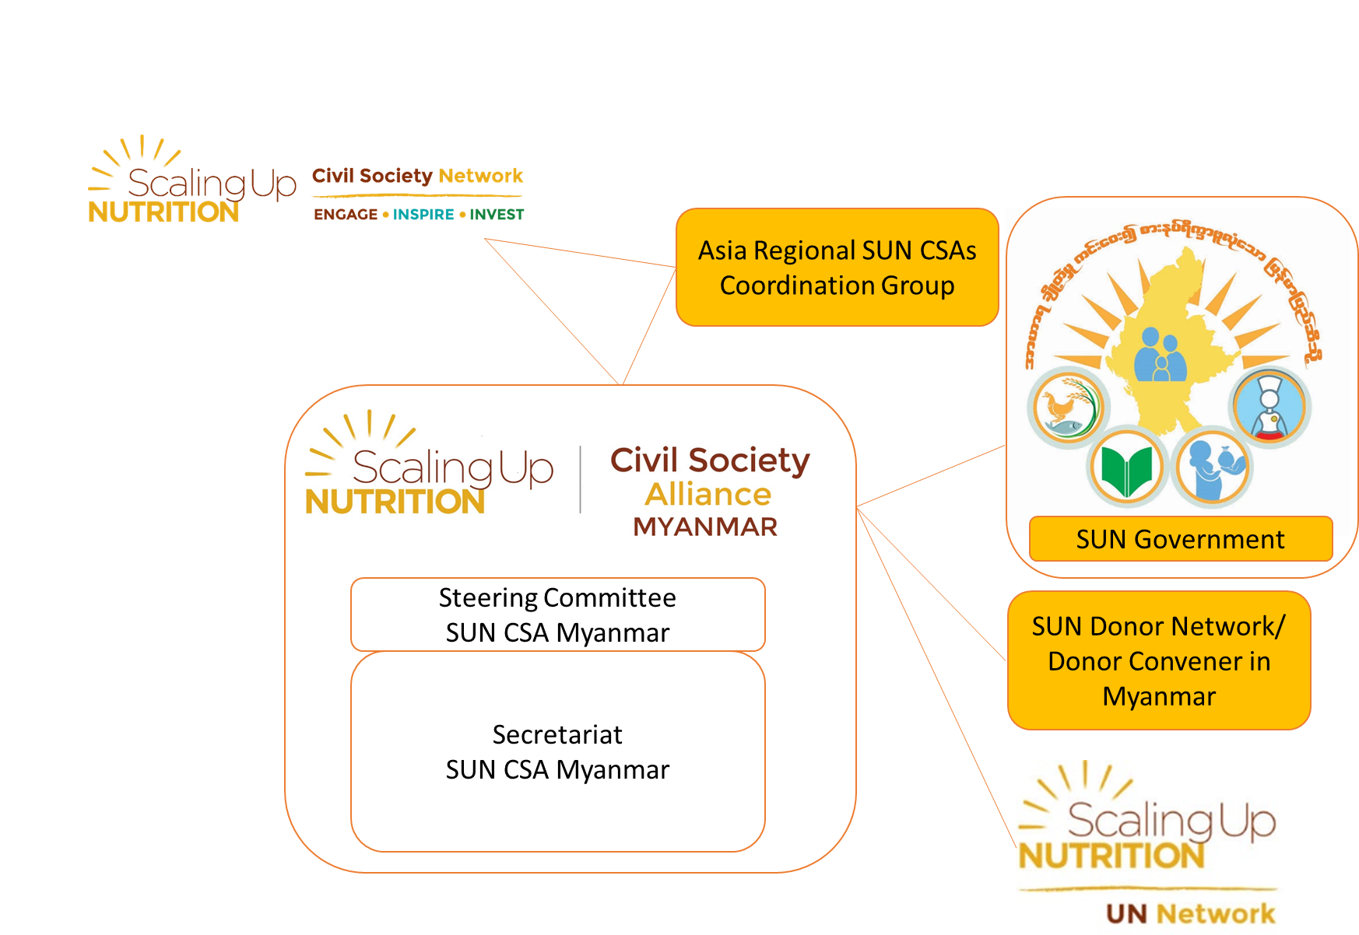

Activities of the SUN CSA Myanmar
In alignment with strategic objectives of the SUN Movement 2016-2020 and building on past achievements including the formation of a functioning CSA with growing membership, the key activities of the Alliance moving forward will include:
- Expanding and sustaining an enabling political environment, specifically:
- Continuing to grow and strengthen a sustainable civil society alliance in Myanmar that is aligned with national priorities and the global SUN movement;
- Advocate for policy coherence and that sector policies that are consistent with nutrition objectives.
- Prioritizing effective actions that contribute to good nutrition, specifically:
- Documenting and disseminating evidence-based best practices for scaling up nutrition in Myanmar.
- Implementing actions aligned with national common results framework (CRF), specifically:
- Building the capacity of CSOs to implement nutrition activities that contribute to national priorities and are aligned with the CRF;
- Harmonizing nutrition messages in alignment with the CRF.
- Effectively using and significantly increasing financial resources for nutrition, specifically:
- Working closely with other SUN Networks to sensitize policy makers and opinion leaders to increase financial resources for nutrition and support the scale-up of effective nutrition policies and programs.

Current membership
The SUN CSA Myanmar is made up of representatives from national, regional and international organisations and networks working in various areas including: agriculture, health, humanitarian and aid assistance agencies, advocacy and research entities, consumer groups, and other. Organisations within the SUN CSA are working together to build capacity and maximise resources to ensure the greatest impact on nutrition.

Who can be a member
Following the principle of inclusiveness of the SUN movement, membership is open to any civil society organization or institution in Myanmar wanting to link with the SUN CSA. Joining the CSA should however be an institutional choice and not an individual one. Organizations that are already members of another network of the SUN Movement will not be eligible for SUN CSA membership.
Community-based, local, regional, national and international non-governmental civil society organizations (CSOs) as well as professional associations engaged in nutrition-specific and/or nutrition-sensitive programming are eligible for membership. In order to ensure that the SUN CSA contributes to a country-led effort to scale up efforts to improve nutrition, the alliance will actively work to increase membership and enhance participation of local and community-based CSOs. Each member will have an equal status and is requested to actively participate. Applications for membership will be reviewed by the CSA Secretariat and approval will be the norm except in special circumstances where an applicant’s goals or interests conflict with those of the SUN Movement.
Individuals working on direct nutrition interventions as well as those from organizations for whom nutrition may not be a strategic focus are welcome to become friends of the SUN CSA to follow the efforts of the Alliance and receive regular progress updates.

SUN CSA partners
The SUN CSA will also develop relationships with other non-member partners to support the network’s efforts and share experiences.

Guiding principles
By joining the SUN CSA, members commit to embracing and adhering to the SUN Principles of Engagement. These principles should inform and guide all aspects of the life of the SUN CSA both at the global level and in countries.
Figure 2: SUN Principles of Engagement
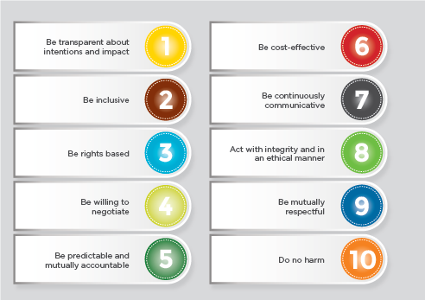

Joining statement and commitments
Upon joining the SUN CSA, organisations will provide a short description of what they are planning to bring to the network.

Examples of type of support organisation can commit to bringing
We understand that not all organisations have the possibility to bring resources to the network. However, below are examples of the type of support you could commit to provide if your organisation is able to do so.
- Coordinate and /or provide access to technical support forums / online question and answers spaces;
- Upload specific tools and resources – guidance notes, existing guides, tool kits, training materials, advocacy materials
- Provide access to and/or support attendance of SUN CSA representatives to training opportunities,
- Organise / contribute expertise at webinars (around specific topics to be recorded and available offline)
- Provide translation support (simultaneous translation at events, translation of key materials, language dialogues, capacity building strategy dimensions in various languages)
- Facilitate documentation of country experiences
- Specific ways to strengthen capacity for CSAs to contribute to ensuring efforts happen at the district level
- Leveraging technical assistance in SUN countries, etc…

Process for becoming a member
- Express interest in becoming a member by completing forms in Annex 1, Annex 2 and registration sheet, signed by the responsible person in your organisation and return to
Khin Youn Hlwar Htun
Senior Membership Support Officer
khinyounhlwar.htun@savethechildren.org

Soe Nyi Nyi
Nutrition Advocacy Advisor
soenyi.nyi@savethechildren.org
Secretariat of the SUN CSA Myanmar
Save the Children’s Office
1st Floor, Salmon Business Centre
224, U Wisara Road, Bahan Township

- Membership requests will then be reviewed by the SUN CSA Secretariat to ensure compliance with SUN principles, as per disclosure form completed, and taken to the Steering Committee of the SUN CSA, or appropriate committee should membership expand rapidly. Should an applying organisation not be compliant with SUN principles, application will become ineligible for membership. However, the organisation could still be considered as a friend of the network and kept informed of the SUN CSA activities and is entitled to apply for membership to the network at a later stage once any potential conflicts of interests / non-compliance have been resolved.
- Should objections be expressed, the membership request will be taken to a voting stage from the SUN CSA Steering Committee members.
- Membership will last for one year from the date of receiving confirmation of membership acceptance from the Secretariat. Member organizations will need to renew the membership before the expiration date. The Secretariat team will send a reminder for membership renewal to the organizations one month prior to the date of membership expiration.

Process for becoming a friend
Express interest in becoming a friend of the network by contacting the Secretariat team. By being a friend of SUN CSA, your organization or institution will be able to engage with the SUN CSA such as being invited to participate in SUN CSA General Assembly, exchanging capacity and expertise, etc.

What being a member of the SUN CSA means for YOUR organisation

1. A monthly update of the SUN CSA activities
2. Access to a number of resources from the SUN CSN to support in country efforts (documents from other SUN CSAs to guide your efforts, portal to key tools and resources and access to SUN CSA specific tools and resources)
3. Being part of the SUN movement
4. Being part of a community of stakeholders engaged in addressing malnutrition from the bottom-up
5. Being part of coordinated and harmonised advocacy efforts
6. Being able to take part in cross-learning efforts and improving your own practice from lessons learnt
7. Contributing to national events such as Annual General Assembly and joint SUN MSP events during which you commit to engaging in and organising events, activities and other efforts for addressing malnutrition whatever the focus of YOUR organisation is, as part of the SUN Civil Society Alliance efforts, once a year.
8. Opportunities to influence global directions in nutrition through advocacy efforts at key global and regional moments (post-2015, Road to Rio, International Year of Family Farming)
9. Participation in key SUN events in country, regionally and golbally (through open nominations process and within limited funding available, with priority given to country SUN CSA representatives)
10. Being part of thematic and / or technical assistance working groups
11. Cross-linking websites and social media sites – improved visibility of your organisation’s efforts
12. Participation in exchange learning activities

What can YOUR organisation CONTRIBUTE to the SUN CSA
1. Expertise in a specific area
2. Technical Assistance for in-country efforts
3. Contribute to shaping and implementing the SUN CSA’s capacity building strategy
4. Provide opportunities, when possible, for expanding the network and supporting its effective functioning and implementation of its various strategies to ultimately ensure we reach the communities that are suffering from malnutrition in SUN countries
5. Cross-linking website – improved visibility of SUN CSA efforts
6. Timely response/ feedback given to the communications made by the Secretariat and Steering Committee whenever required.

It is important to note that joining the SUN CSA Myanmar will not give you access to financial resources. The SUN CSA has very limited resources and is always looking for additional support to be able to more effectively function and implement its various strategies and activities.

Annex 1 - Membership Application Form
Name of organisation:

Details and description of organisation:

Organisation website:

Organisation representative and contact details (name, physical address, email address, skype, telephone and fax):

Statement
By joining the SUN CSA Myanmar, NAME OF ORGANISATION commits to (in no more than 200/300 words) – Commitments should be expressed in terms of concrete actions (staff time dedicated, expertise provided, alignment at country level and what this looks like, translation of key documents, hosting language dialogues, etc…)::

* Please confirm you have completed corresponding xls registration sheet and that this sheet is attached by ticking this box □
* Please confirm you are happy for the SUN CSA secretariat to manage your contact details and use for SUN CSA related efforts.
□ Yes I am happy for SUN CSA to manage my organisation’s contact details and use for SUN CSA related efforts, including posting on SUN CSA web page.
□ Yes I am happy for SUN CSA to manage my organisation’s contact details and use for SUN CSA related efforts, but please consult me before posting on SUN CSA web page.
□ No, I would prefer the SUN CSA secretariat did not use for SUN CSA related efforts without prior notification.
** Please note that by becoming a member you also commit to reporting on the commitments and related efforts to the SUN CSA secretariat at least on a bi-annual basis, and more often if required.

Name of SUN CSA Focal from the Organization
Name | Title | Contact Information
Focal:………………………………………….. | …………………………………. | Email:…………………………………..  Phone:………………………………….
Alternate (1):……………………………….. | …………………………………. | Email:…………………………………..  Phone:………………………………….
Alternate (2):……………………………….. | …………………………………. | Email:…………………………………..  Phone:………………………………….

Date ___________________________________
Organisation representative Name and Position ___________________________________
Signature of organisation representative ___________________________________

Only for the Secretariat
Date of Membership Acceptance: ___________________________________
Date of Membership Expiration: ___________________________________
Please return completed, validated and signed form by email to khinyounhlwar.htun@savethechildren.org and soenyi.nyi@savethechildren.org or return signed hard copy to Secretariat of the SUN CSA Myanmar, Save the Children’s Office, 1st Floor, Salmon Business Centre, 224, U Wisara Road, Bahan Township

Annex 2 – Disclosure form for applying members
Organisations applying for membership to the SUN Civil Society Alliance should also complete and get organisation official to sign the below disclosure form.
The applying organisation is in charge of ensuring the disclosure form is accurate and complete.
It is also the responsibility of the applying organisation to ensure there is a process for internal regular review of commitments and disclosure as well as periodic updates of disclosure forms on an annual basis.
The SUN CSA will not be responsible for incorrect information submitted or for updating out of date information.
Disclosure Form for SUN CSA membership application
By applying to join the SUN CSA Myanmar, NAME OF ORGANISATION commit to | Yes | No
Honour commitments made in the membership application forms
BE TRANSPARENT ESPECIALLY ABOUT INTENTIONS AND IMPACT: Stakeholders will engage in transparent behaviour in all interactions within the context of the SUN Movement. Stakeholders also commit to establishing rigorous evaluations of the impacts of collective action and the contributions of individual stakeholders.
BE INCLUSIVE: The SUN Movement is open to all stakeholders that demonstrate their commitment to its goals. Exclusion should be avoided if at all possible.
BE RIGHTS-BASED: All stakeholders are expected to act in accordance with a commitment to uphold the equity and rights of all women, men and children.
BE WILLING TO NEGOTIATE: All SUN Movement stakeholders are responsible for offering coherent and responsive support to national governments as they implement their nutrition policies and plans. Stakeholders will seek to resolve divergences in approach or divergent or competing interests whenever they arise.
BE PREDICTABLE AND MUTUALLY ACCOUNTABLE: All stakeholders are collectively accountable for their joint commitments; they should follow up on these commitments in a predictable way and be mutually accountable for the commitments being delivered as intended.
BE COST-EFFECTIVE: Stakeholders should be guided by available evidence about policies and actions that have the greatest and most sustainable impact for the least cost.
BE CONTINUOUSLY COMMUNICATIVE: All stakeholders are committed to the regular sharing of their intentions, actions, experiences and concerns.
ACT WITH INTEGRITY AND IN AN ETHICAL MANNER THAT ENHANCES THE REPUTATION AND IMPACT OF THE SUN MOVEMENT: Stakeholders should recognize that both personal and institutional conflicts of interest must be managed with the highest degree of integrity.
BE MUTUALLY RESPECTFUL AND SEEK TO EARN THE TRUST OF THOSE WITH WHOM YOU ARE WORKING: Stakeholders make different contributions to the collective effort. Building the trust needed for collaboration requires respect for these differences.
DO NO HARM: All stakeholders are committed to ensuring that all mothers and children everywhere are empowered to realise their right to proper nutrition. Whatever action is being undertaken, the wellbeing of mothers and children at risk of under-nutrition should be the primary consideration. For this reason, the possible negative consequences of all actions
Always uphold and respect children's rights.

NAME OF ORGANISATION hereby declare that | Yes | No
An official internal process has been followed in order to apply for this membership.
A particular individual or committee been assigned to maintain the relationship with the SUN CSA
There is a regular review of internal processes to ensure the information provided in the disclosure document is up to date and commit to annual review of information provided for updating the SUN CSA database should this be required.
There is continual monitoring of new legislation that may impact the organisation’s contribution to the network and corresponding disclosure form
Consideration of conflicts of interest issues is an ongoing agenda item in organisation’s contribution to SUN CSA efforts
A risk register been developed and a process been put in place for regular monitoring established with regards to the membership to the SUN CSA.
There are mechanisms to ensure ongoing communication of potential changes in member organisation status in place and clear within the applying organisation
The organisation abides to existing national legal obligations and regulations, and applicable international codes and obligations (including the International Code of Marketing of Breast Milk Substitutes) – please consider this for each of the country in which the organisation is present
The organisation activities respect local cultures
The organisation has and will continue respecting human rights
The organisation has and will continue respecting UN conventions, global treaties, or others
The organisation is not associated with activities of human trafficking
The organisation is not associated with activities or partnerships they feel should be declared. If so, please list. (For example, an organisation should declare any association with or affiliation to businesses potentially violating the BMS code of conduct in certain countries).

By becoming a member, the organisation understands it does not have decision-making power, which remains bound to the Steering group of the network, with guidance from SUN Civil Society Alliances in SUN countries

Date ___________________________________
Organisation representative Name and Position ___________________________________

Signature of organisation representative ___________________________________
Please return completed, validated and signed form by email to khinyounhlwar.htun@savethechildren.org and soenyi.nyi@savethechildren.org or
return signed hard copy to Secretariat of the SUN CSA Myanmar, Save the Children’s Office, 1st Floor, Salmon Business Centre, 224, U Wisara Road, Bahan Township

Annex 3: Organizational Programmatic Information
Name of Organization: ……………………………………..
Type of Nutrition/ Food Security Intervention | Geographical Coverage (State/ Region & Township) | Time Frame

Note: We encourage member organizations to provide requested information as comprehensive as possible as it will help the Secretariat and the Steering Committee to facilitate effective collaboration and coordination within the CSA at different levels: township, state/ region and national.

Date ___________________________________
Organisation representative Name and Position ___________________________________

Signature of organisation representative ___________________________________

Please return completed, validated and signed form by email to cherry.win@savethechildren.org, khinyounhlwar.htun@savethechildren.org and soenyi.nyi@savethechildren.org or
return signed hard copy to Secretariat of the SUN CSA Myanmar, Save the Children’s Office, 1st Floor, Salmon Business Centre, 224, U Wisara Road, Bahan Township

